Student Portal Updates – Entrance Counseling and MPN

Definitions
Type Aid (AWD.TYPEAID) = “B” – Fed Direct Sub Loan
Type Aid (AWD.TYPEAID) = “C” or “H” – Fed Direct Unsub Loan
Type Aid (AWD.TYPEAID) = “I” – Fed Direct Grad PLUS Loan
Criteria
- Entrance Counseling:
  - Fed Direct Sub Loan, Fed Direct Unsub Loan,
    - If Type Aid (AWD.TYPEAID) = “B”, “C”, or “H”
And Accept Status (AWD.ACPTST) = “A”
And Total Accepted (AWD.TOTACPT) > 0
And Total Paid (AWD.TOTPAID) = 0
And Entrance Interview Date (BIO.ENTINTC) Is Blank
Loan Status (FLO.LOANSTAT) = “A”
Then add Entrance Counseling to required documents
  - Fed Direct Grad PLUS Loan
    - If Type Aid (AWD.TYPEAID) = “I”
And Accept Status (AWD.ACPTST) = “A”
And Total Accepted (AWD.TOTACPT) > 0
And Total Paid (AWD.TOTPAID) = 0
And Loan Status (FLO.LOANSTAT) = “A”
And Doc ID (TRS.STYPE) = “GRDPLUS” Does Not Exist
Then add Entrance Counseling to required documents
- Master Promissory Note (MPN):
  - Fed Direct Sub Loan, Fed Direct UnSub Loan, Fed Direct Grad PLUS Loan
    - If Type Aid (AWD.TYPEAID) = “B”, “C”, “H”, or “I”
And Accept Status (AWD.ACPTST) = “A”
And Total Accepted (AWD.TOTACPT) > 0
And Total Paid (AWD.TOTPAID) = 0
And Loan Status (FLO.LOANSTAT) = “A”
And Loan Prom Note Status (FLO.PROMSTAT) = Is Blank, “N”, or “R”
Then add Master Promissory Note to required documents
“To Do” Content
- Entrance Counseling
To complete the Loan Entrance Counseling requirement for your federal student loan, please go to: https://studentaid.gov/entrance-counseling/ to log in using your Federal Student Aid ID (FSA ID). This is a requirement for UK, even if you completed it at another school.
If you no longer need the loan, please contact your financial aid counselor.

- Master Promissory Note (MPN)
To complete your electronic Master Promissory Note (MPN) for your federal student loan, please go to https://studentaid.gov/mpn/ to log in using your Federal Student Aid ID (FSA ID). You must provide the names of two references with different U.S. addresses who have known you for at least three years. Additionally, you will be asked to provide the address and telephone number for each one. The first reference should be a parent or guardian.
If you no longer need the loan, please contact your financial aid counselor.
ProSAM Screen Shots
- FLO.LOANSTAT
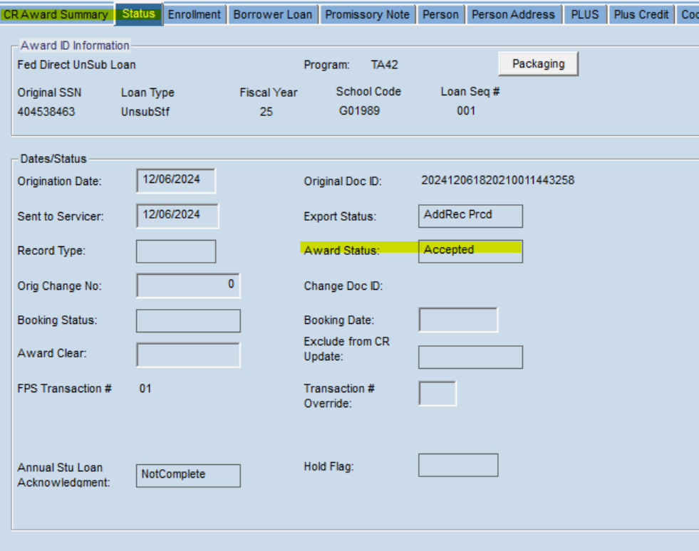
- FLO.PROMSTAT
